**Ideation Phase**

**Define the Problem Statements**

|  |  |
| --- | --- |
| Date | 19 September 2022 |
| Team ID | PNT2022TMID49916 |
| Project Name | Project – Skill/Job recommender application |
| Maximum Marks | 2 Marks |

**Customer Problem Statement Template:**

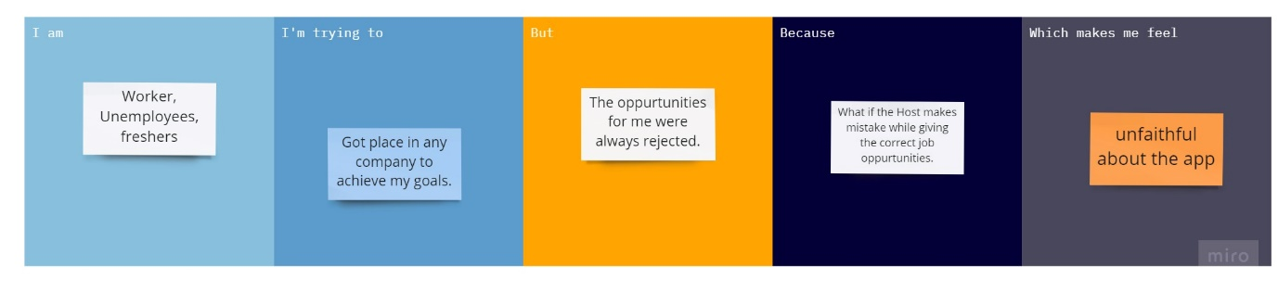

**Reference:**

https://miro.com/app/board/uXjVPSMPQW